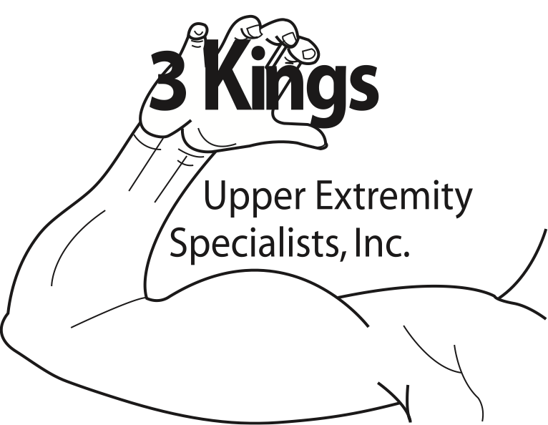

Presents

**How to dose therapeutic exercise to the upper extremity using a tissue based treatment approach**

**April 28-29, 2017 (Friday 6-8:30pm, Saturday 8-1pm)**

**9 contact hours**

**Location: Premiere Physical Therapy**

**13947 Beach Blvd (Between Hodges and San Pablo)**

**Instructor: Chris Kopp PT, OCS,CMPT**

**Cost: $225 ($202.50 if you have attended a previous course)**

**\*Limited to 12 participants**

It is important for therapists to understand the various functional qualities of exercise dosages and appropriate modifications to achieve optimal outcomes. This lab intensive and evidence-based course will assist therapists with the design and implementation of therapeutic exercises for common musculoskeletal conditions of the UE. The concept of medical exercise therapy (MET) will be introduced and discussed to understand how tissue histology including injury and repair applies to the use of therapeutic exercise as an intervention. The use of kinematic taping as well as mobilization with movement will also be incorporated within the course material.

**OBJECTIVES:**

Upon completion of the seminar participants will be able to:

1. Better understand the concept of medical exercise therapy
2. Implement various exercise interventions for common UE musculoskeletal conditions
3. Incorporate tissue histology into the design of exercise interventions
4. Progress patients with phases of rehabilitation based on presentation

**Course Agenda:**

**Friday Evening**

5:30-6:00: Welcome and Registration

6-7:15: Lecture discussing the concept of medical exercise therapy, tissue histology and manual therapy

7:15-7:30: Break

7:30-8:30: Wrist and Hand Lab

**Saturday Morning**

8:00-8:30 Questions

8:30-10:00 Elbow Lab

10:00-10:15 Break

10:15-12:30 Shoulder Girdle Lab

12:30-1:00 Questions and answers

**INSTRUCTOR BIOGRAPHY**

Chris Kopp, PT, OCS, CMPT graduated Magna Cum Laude from the University of North Florida physical therapy program and has been practicing for over 20 years primarily as an outpatient orthopedic physical therapist. He currently is the owner and director of Premier Physical Therapy and Rehabilitation of Jacksonville and serves as one of the principal faculty for Florida Institute of Orthopedic Manual Therapy. Chris is a dynamic speaker who believes strongly in post graduate education and is an experienced instructor both in the academic and clinical setting. He has presented both locally and nationally and has been a board certified Orthopedic Clinical Specialist since 2006. With extensive continuing education for the spine and extremities, Chris brings a wealth of knowledge and experience to his course presentations and believes strongly in the role and responsibility of clinical mentors.

**CANCELLATION POLICY:**

Due to small class size, there will be NO refunds if cancellation received on or after April 15, 2017. Prior to April 15, refunds will be issued minus $25 administration fee. If you are able to find someone to take your place, that person can pay you directly so that that you will receive a full refund. You will just need to contact me to let me know the name of the person taking your place. **3Kings UE Specialists will not refund any expenses associated with travel expenses or fees for registering online, only course costs.**

**CONTINUING EDUCATION CREDIT:**

*PTs and PTAs will have to submit this course individually for approval(This can also be done prior to the course. Cost is $20). 3Kings UE Specialists will provide documentation needed to submit the course

*Out of state therapists please contact your board for approval

*3Kings Upper Extremity Specialists will provide CEUs to Florida and Alabama OT/OTAs

**OTHER INFORMATION REGARDING COSTS:**

*To keep costs and class size low, handouts will be emailed to participants. Participants will be responsible for dinner Friday evening. Light snacks will be provided on Saturday

*Dinner will NOT be provided Friday evening, please remember to bring food. There is a restaurant next to the clinic also, Rice Bowl

*PLEASE CONTACT 904-803-4480 OR [3KINGSUESPECIALIST@GMAIL.COM](mailto:3KINGSUESPECIALIST@gmail.com) with any questions

**Mail in payment receipt**

Name:_________________________________________________OT/OTA/PT/PTA

Address:_______________________________________________

_______________________________________________________

_______________________________________________________

Phone number (Please include number to be reached at day of course)____________________

Email address:___________________________________________________

License #__________________________________

Employer:___________________________________

Amount enclosed: ___$225 if you have not attended a previous course ___$202.50 If you have attended a previous course

*Please make check payable to 3Kings Upper Extremity Specialists and mail to:

56 Solana Rd

Ponte Vedra Beach, FL 32082